CNMUNM Transfer Station – All Aboard the Humanities Transfer Bus!!

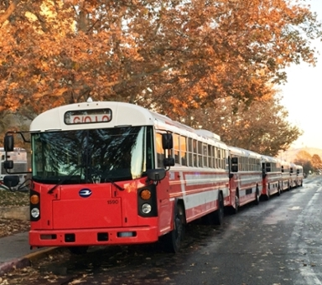

UNM Transfer Admissions applications are DUE by Monday, November 15th 2021 for Spring 2022

NM Humanities Now will offer mini-workshops with information and resources for CNM Humanities Students planning to transfer to UNM - English, History, Anthropology, Philosophy, Languages, American Studies, Chicana/o Studies, Native American Studies & Communication. For additional UNM Humanities majors see: http://artsci.unm.edu/advisement/cnmunm-humanities-transfer.html

WORKSHOP SESSIONS:
Monday, 9/27/21 12:00 – 1:00pm Getting Started on the Transfer Journey https://unm.zoom.us/meeting/register/tJEqcuiopzwjGdYrUHkdLWolJ90BwwOF1e2x
We will look at the transfer timeline and when to do certain steps to get ready!

Monday, 10/11/21 12:00 – 1:00pm Never Too Early to Meet Your Advisor
https://unm.zoom.us/meeting/register/tJIkd-yprjssHd1nHDW0T7CKXcdTjQVivgnz
We will share information on advisors for the Humanities majors – meet with them to discuss your academic plans, learn about degree requirements, and what CNM courses can apply to UNM degree.

Monday, 10/25/21 12:00 – 1:00pm Let’s Talk Admissions & Financial Aid
https://unm.zoom.us/meeting/register/tJ0lc-ugqDoqGdIUJLQMsci9Hl5xP2H_QsKY
We will introduce you to UNM Admissions and Financial Aid reps, share the resources you will need, and you get to ask your questions.

Monday, 11/1/21 12:00 – 1:00pm Final Preparations to Board the Transfer Bus
https://unm.zoom.us/meeting/register/tJIpc-qgqT8sE9M9eZz93j3XwuG1OtiSe2lX
We will address any final admissions application questions and introduce other helpful UNM resources for your successful transfer journey!

